INFORMATION TECHNOLOGY THEORY TEST
Hardware

Question 1
Match COLUMN A with COLUMN B. Then indicate whether they are input/output/storage devices example, 1.11 K – storage device.
COLUMN A |  | COLUMN B
1.1 | Electronic Whiteboard | 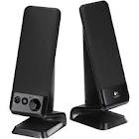 A
1.2 | Trackballs | 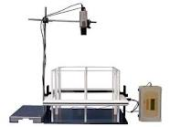B
1.3 | Plotters | 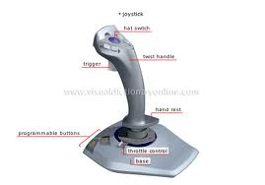 C
1.4 | Data projector | 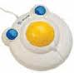 D
1.5 | Smart Card | 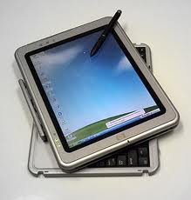 E
1.6 | Web Cam | 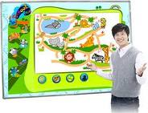 F
1.7 | Speaker(s) | 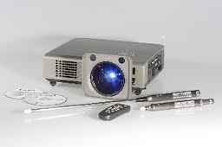 G
1.8 | Joystick | 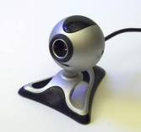 H
1.9 | Digital Camera | 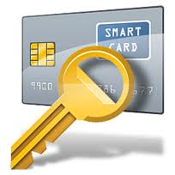I
1.10 | Touch Screen | J
10 x 2 /20/
Question 2
Briefly explain the purpose of the following:
2.1 Interactive whiteboards 2
2.1.2 Biometrics 2
2.1.3 Name two different biometrics devices in the given images.
A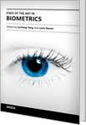 | 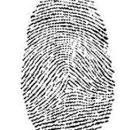B

2.1.3 A ………
B …….. 2
/6/
Question 3
3.1 Identify the following ports and the connectors and state clearly what their purpose is?
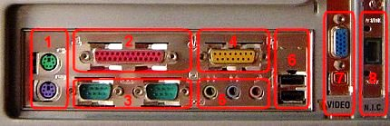
3.1. 1 …..
2 …..
3 …..
Etc. 8
3.2 Explain the following symbols?
3.2.1 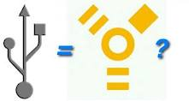 2
3.2.2 1
/11/
Question 4
4.1 What is the purpose of an operating system 2
4.1.2 Give three examples of operating systems? 3
4.1.3 What is the purpose of utility programs? 2
4.1.4 Give three examples of utility programs? 3
/10/

Question 5
You are ask to write a program after you have done the IPO analysis. You decide to include GUI components in the program.
5.1 Explain the terminology GUI? 1
5.1.2 What are the characteristics of a good GUI? 4
5.1.3 Name two typical GUI components that could be used as part of the interface for capturing new
Information in the programming language that you have used and explain briefly why you would
utilize each of these components. 4
5.1.4 Name two types of data validation that could be performed on the data that was input to
in a given program. 2
5.1.5 Name two types of bugs that can occur in a program. 2
5.1.6 Debugging can result in the occurrence of logical and syntax errors within a program.
Briefly explain the difference between syntax and logical errors? 2
5.1.7 Name two debugging techniques? 2
/17/
Question 6
The one Laptop per child initiative proves to be successful as the Kliptown Youth program support educational activities and after –school activities in the very poor community of Kliptown and Soweto. This initiative provide low cost computing to under privileged communities around the world.
These learners want to spend prolonged periods of time in front of the computer and youth leaders will have to explain to them that computers can have an adverse effect on their health.
    - List THREE ways in which computers can possibly contribute to ill health. 3
6.1.2 List THREE practical precautions that these learners can take to prevent their health being adversely affected by computers. 3
/6/
TOTAL: 70

